**How to install the R-package “crmPack”   
for model-based dose escalation in R***Daniel Sabanes (*[*sabanesd@roche.com*](mailto:sabanesd@roche.com)*)  
Version 2.1 (December 2014)*

Following this installation guide, you will install the R-package “crmPack” on your local computer with your local R installation. Please note that it has nothing to do with the remote RStudio that you can access on <https://r.roche.com>. Your local R and the remote RStudio on the server are completely independent. We assume here that you have already installed R or RStudio on your computer.

1. First, you have to install JAGS (“Just Another Gibbs Sampler”) on your computer. Note that this requires you to have administrative rights on your computer.
   1. Click on the following link to visit the JAGS webpage:  
      <http://sourceforge.net/projects/mcmc-jags/files/JAGS/>
   2. Download the JAGS installation program suitable for your computer by clicking on the top link in the JAGS webpage:  
      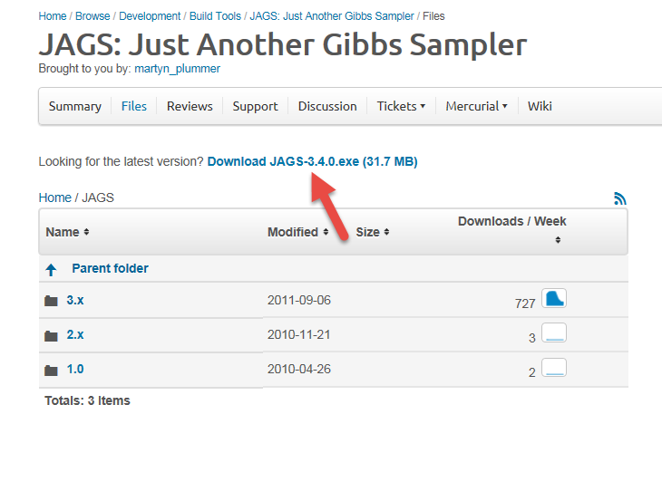
   3. Run the JAGS installation program by executing the downloaded file, and clicking through and confirming all installation setup steps (including warnings).
2. Now we will install the latest version of the R-package “crmPack” to your computer.
   1. Open R or RStudio on your local computer, e.g. by finding it in your Programs list.   
      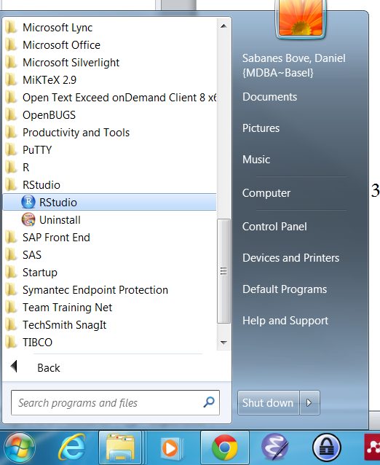
   2. Please copy the following lines into your R console and press Enter:

options(repos=structure(c(CRAN="http://stat.ethz.ch/CRAN/")))

install.packages("httr")

library("httr")

url <-

paste("https://stash.intranet.roche.com/stash/plugins/servlet/archive/projects/RSTAT",

"/repos/crmpack?at=refs%2Fheads%2Fmaster",

sep="")

tmp <- tempdir()

target <- file.path(tmp, "crmpack.zip")

x <- GET(url, config = list(ssl.verifypeer = FALSE))

bin <- content(x, "raw")

writeBin(bin, target)

dir <- file.path(tmp, "crmpack")

unzip(zipfile=target, exdir=dir)

install.packages(c("Rcpp", "RcppArmadillo", "rjags", "ggplot2", "gridExtra",

"GenSA", "BayesLogit", "mvtnorm"), dependencies=TRUE)

install.packages(dir, repos=NULL, type="source")

Please be patient as this may take a minute.

* 1. The successful installation looks like this:  
     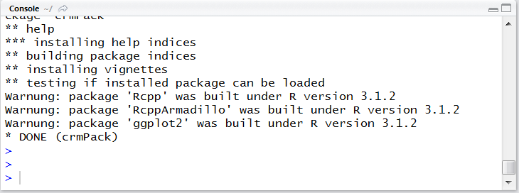

1. Before you can use the R-package “crmPack”, you have to load it into your R session,   
   by typing the command  
   library("crmPack")  
   into your console.  
     
   Note that you have to run library("crmPack") *again* for each *new R session*!   
     
   On the other hand, you only have to do the *installation* process (step 2) *once* on your computer. When you have successfully completed step 2, then only in case you would like to update your “crmPack” installation with a new version, you would have to run completely through step 2 of this installation guide again.
2. In order to read an introductory example to the package, type the following into your console:  
   crmPackExample()  
   In order to get help on specific functions or classes, get a list of all help pages by typing  
   crmPackHelp()

Thank you very much for installing crmPack.   
If you have any questions or feedback, please post on the Hive page:  
<https://roche.jiveon.com/groups/open-source-framework/projects/crmpack>  
Thank you!